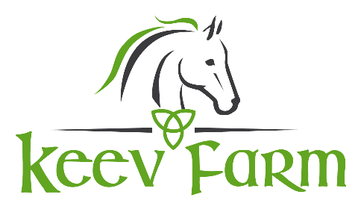

Helping children develop a connection and partnership with our equine friends
while grooming, learning in-hand exercises and riding.

Dear Pony Camper:
Thank you for registering for pony camp! Here is some information to help you get ready.
During camp you will be in small groups of about 5 kids that are your age. If you signed up with a friend or family member and want to make sure you are in their group (or not), please send me an email letting me know. This was also a question on your registration form, if you answered it then you do not have to send me another email. You will have a camp counselor assigned to your group to help you each day. We also have a handful of volunteers to help where needed. I will mostly be in the arena for the groups rotating in for riding lessons. You will also have a Lesson Assistant assigned to you all week to help you in your riding lessons.
You will rotate through crafts, riding, grooming and learning stations in your small group and come together with the other groups for lunch, snack and free time at the end of the day. The sprinkler is sometimes on at the end of the day during free time to cool off (weather dependent). Please bring your water bottle and put your name on it and we’ll encourage you throughout the day to stay well hydrated, especially if the weather is warm. The bathroom that everyone will have access to is attached to the house by the garage. We’ve found that the “real” bathroom is much better for this age group than the Honey Buckets! We will be extra vigilant with hand washing in between stations and before eating. All hard surfaces (bathrooms, counters, tables) will be regularly cleaned.
When you come to camp in the morning, please wear long pants to be ready for your riding lesson. You will have a riding lesson every day. I know the weather can get hot in the summer, especially up in the sunny sandy arena; therefore, you are welcome to bring shorts to change into after riding. Also, boots with a heel (like a paddock boot or a cowboy/girl boot) are the safest to ride in, but don’t worry if you don’t have those kinds of boots. Bring your rain or mud boots or a pair of sneakers. Please leave your open toe shoes such as sandals or flip-flops at home. You may also want your own riding helmet to bring to camp each day (put your name on it). Please only bring equestrian helmets and not bike helmets or helmets from other sports. If you do not have your own helmet, we have plenty of quality schooling helmets in the tack room for you to borrow. Riding jeans or tights can be helpful to protect the inside of your legs from the leathers on the saddle. Some styles have high quality technical fabrics and also have sticky leather or silicone to help you stick to the saddle. If you’re looking to buy new boots, helmets, riding apparel or horse-themed lunch boxes or water bottles for camp, you can go to our local tack store, Tack Room Too in Tumwater at 201 Lee St. SW, Olympia, WA 98501. Tack Room Too is our family-owned business and we support all the local equestrian teams, clubs and shows. Since you are a Keev Farm student, we can extend to you a 15% discount on your pony camp supplies. Make sure you let Tack Room Too staff know you are a Keev Farm Pony Camper so you can receive your discount.
Please see the checklist below to make sure you bring everything you need to camp.
- Signed Liability Waiver (print off the website or we can provide you with one at check in on the first day.
- Wear long pants when you come to camp for riding. Riding tights or riding jeans are helpful to protect legs from the leathers on the saddles but are not required.
- Pack a change of clothes for the end of the day or after riding (in case you get wet from water games or are hot in your long pants).
- Apply sunscreen prior to camp. You can bring extra to reapply.
- Lunch (a refrigerator and freezer are available if needed).
- Water bottle with your name on it.
- Raincoat (weather dependant).
- Sweatshirt, fleece or light jacket.
- An afternoon snack (can be packed in your lunch box)
- Riding helmet (NOT REQUIRED to have your own) with your name on it. No helmets from other sports, please! Helmets designed for riding follow guidelines that protect against various riding related accidents different from other sports. We have a large supply of quality riding helmets available at our facility for students willing to share. A riding helmet (whether it’s our helmets or your helmet) will be required while riding.
- Riding boots (NOT REQUIRED) such as a cowboy/girl boots or paddock boot. Boots for riding help protect toes and have a heel to minimize feet from sliding through the stirrups. Riding boots come in synthetic and leather materials to provide various price ranges.
Please contact me with any questions. We look forward to seeing you at camp!
Tracie O’Brien
Tracie@keevfarm.com
www.keevfarm.com

